1.MySQL [nation]> select name from countries where area>10000000;

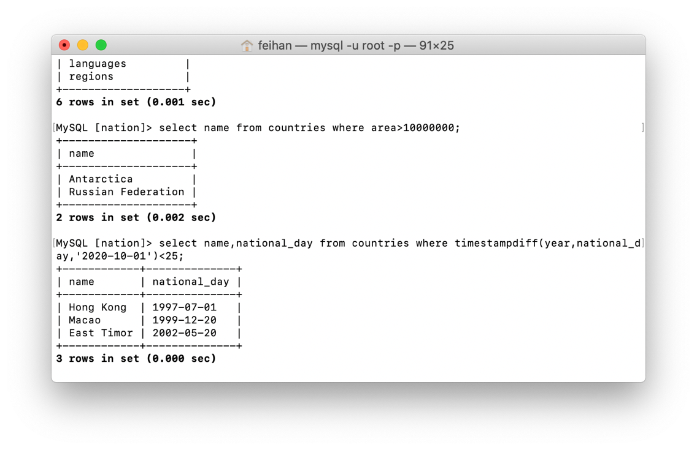

2. MySQL [nation]> select name,national_day from countries where timestampdiff(year,national_day,'2020-10-01')<25;

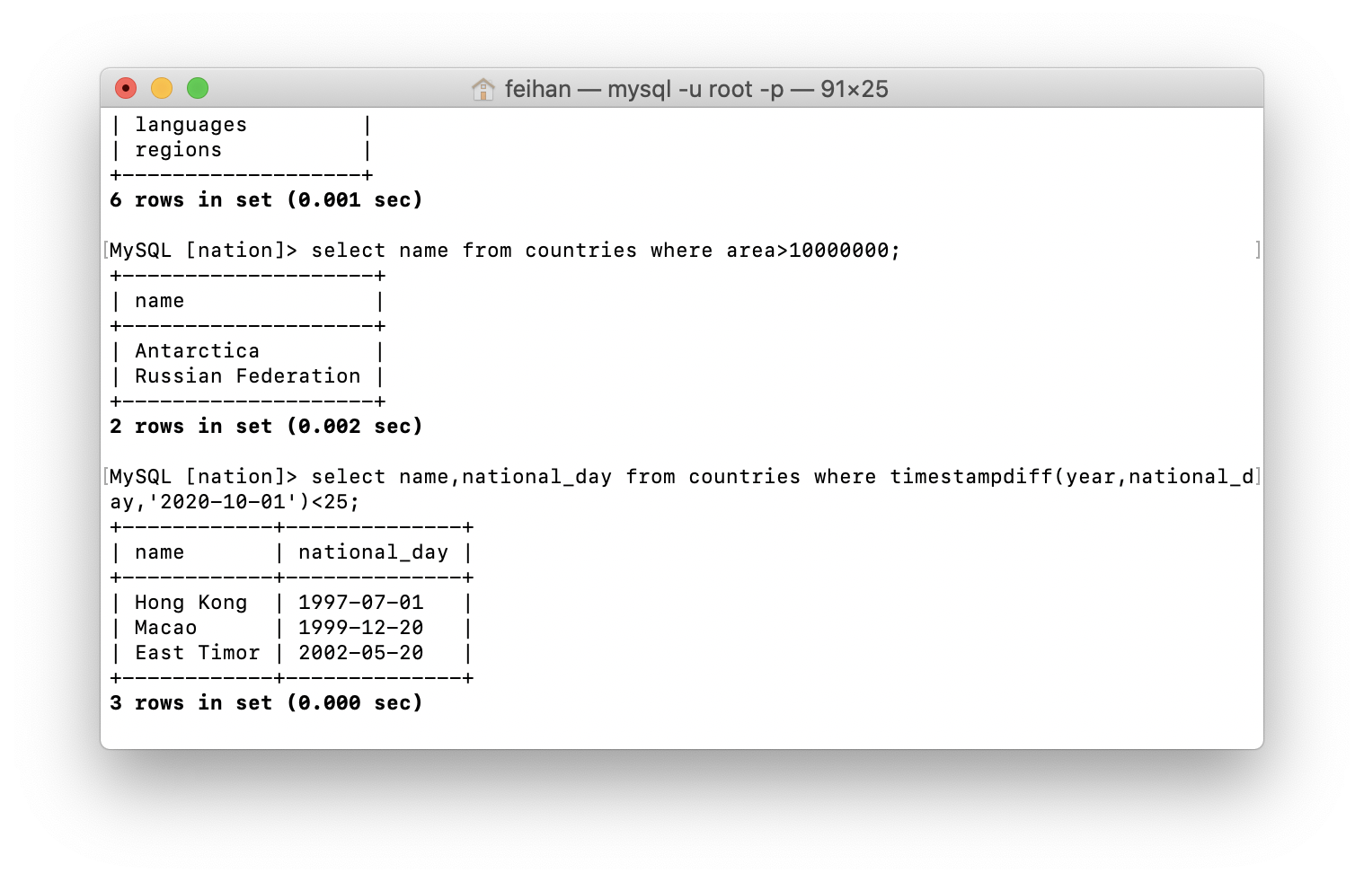

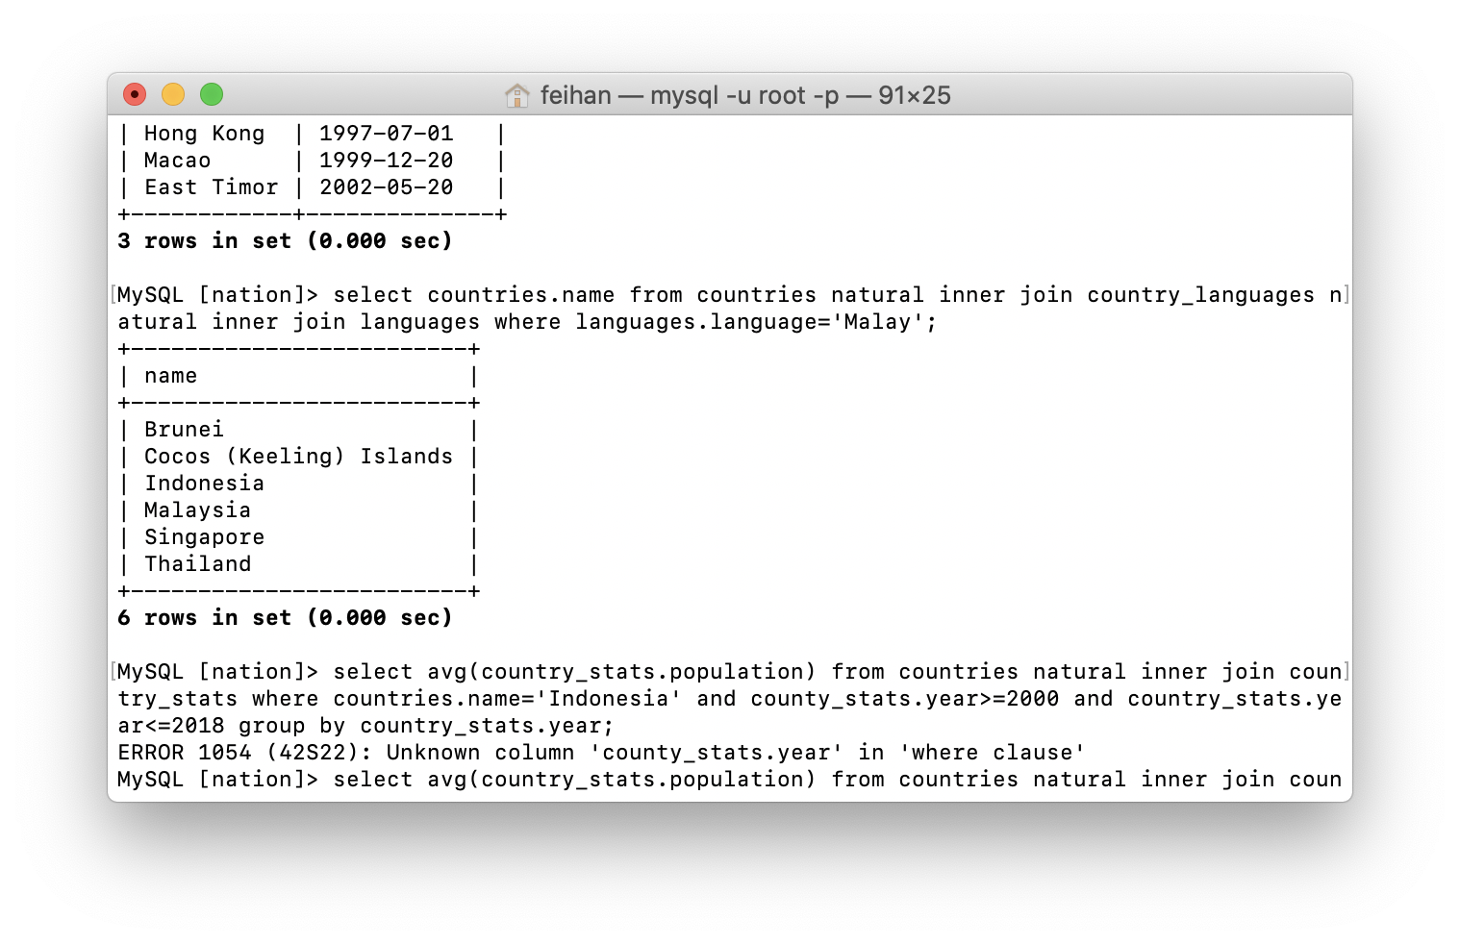3. MySQL [nation]> select countries.name from countries natural inner join country_languages natural inner join languages where languages.language='Malay';

4. MySQL [nation]> select country_stats.year,avg(country_stats.population) from countries natural inner join country_stats where countries.name='Indonesia' and country_stats.year>=2000 and country_stats.year<=2018 group by country_stats.year;

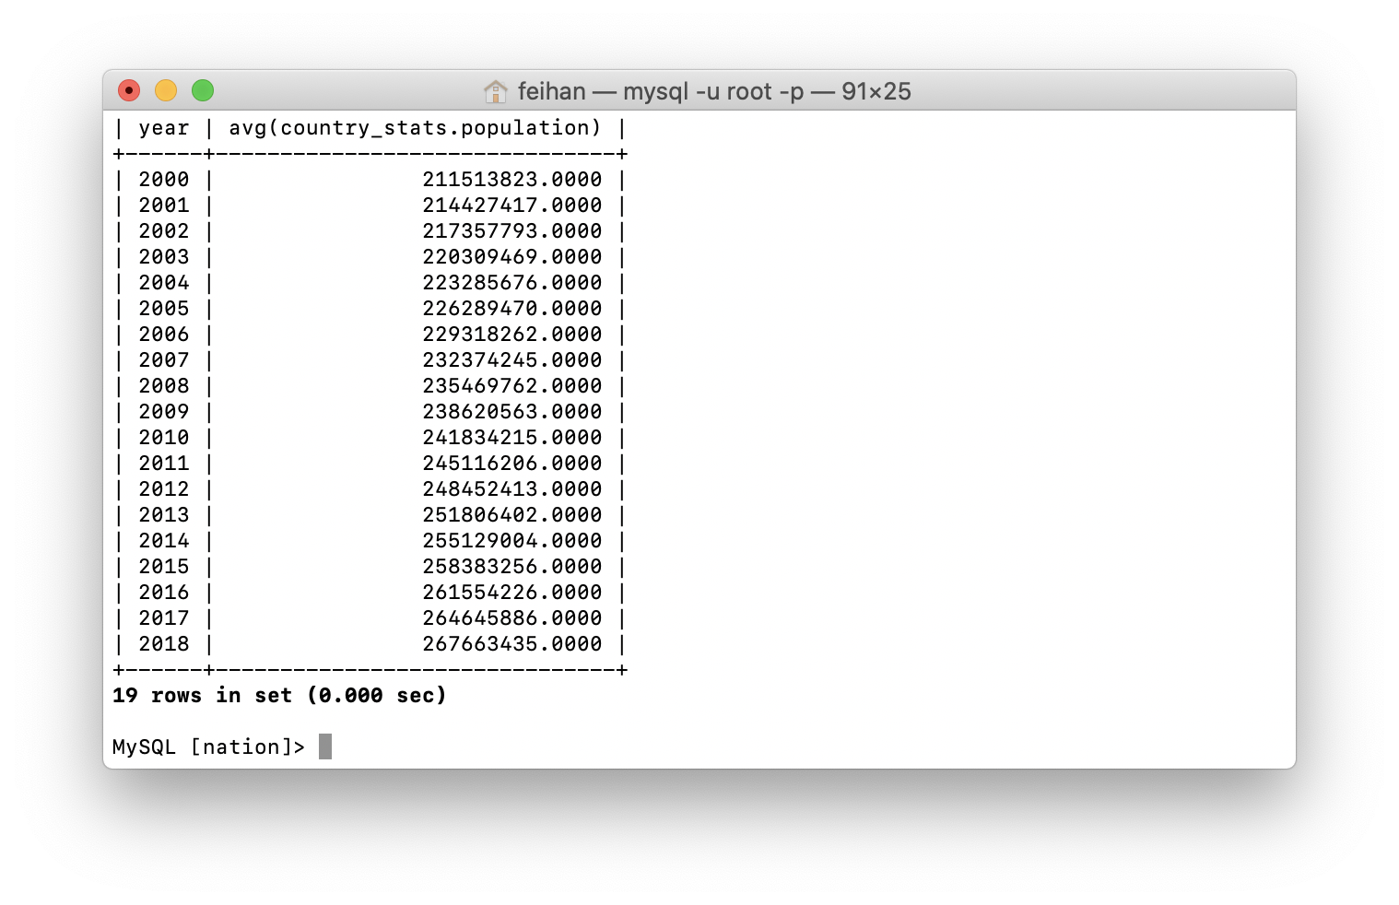

5.

MySQL [nation]> select countries.name as a,country_stats.gdp as b,country_stats.year as c from countries natural inner join country_stats group by a,b,c having country_stats.gdp=max(country_stats.gdp);

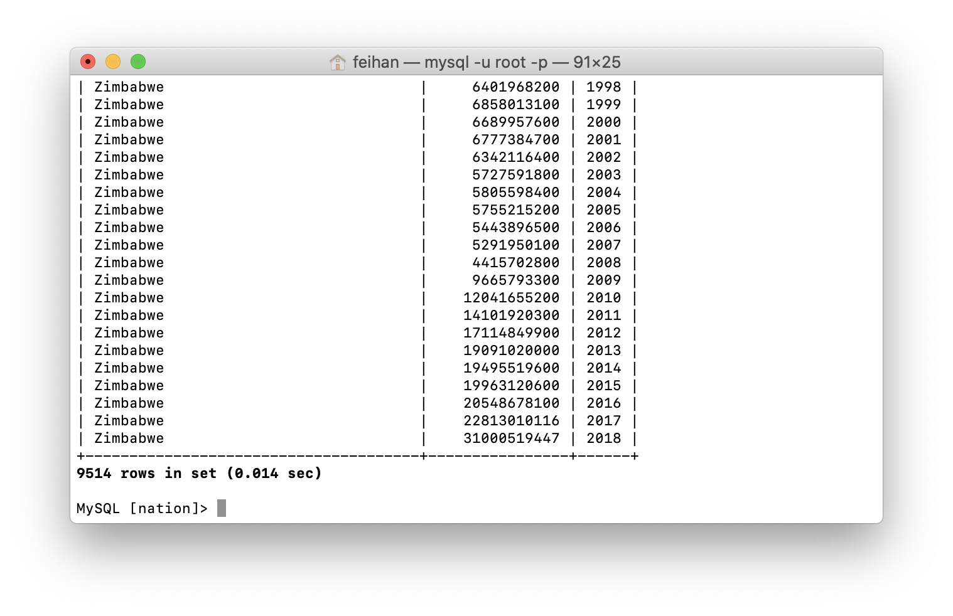

6.

MySQL [nation]> select regions.name as a from countries inner join regions on countries.region_id=regions.region_id group by a having count(countries.name)>15 order by regions.name;

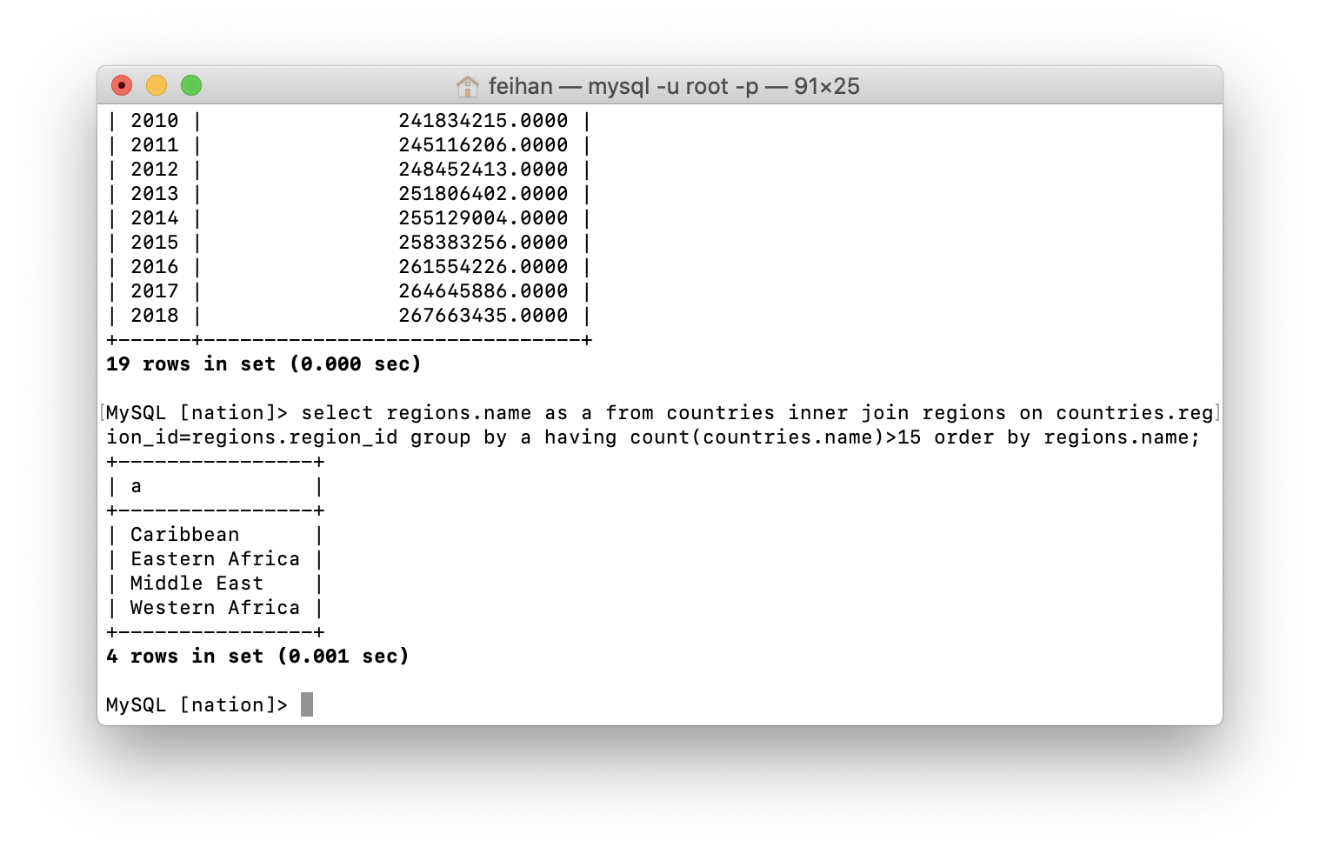

7.

MySQL [nation]> select countries.name from countries natural inner join country_languages natural inner join languages where languages.language='Malay' or languages.language='Sunda';

(UNTUK KASUS BILA YANG DITANYA ADALAH NEGARA DENGAN BAHASA MALAY+BAHASA SUNDA)

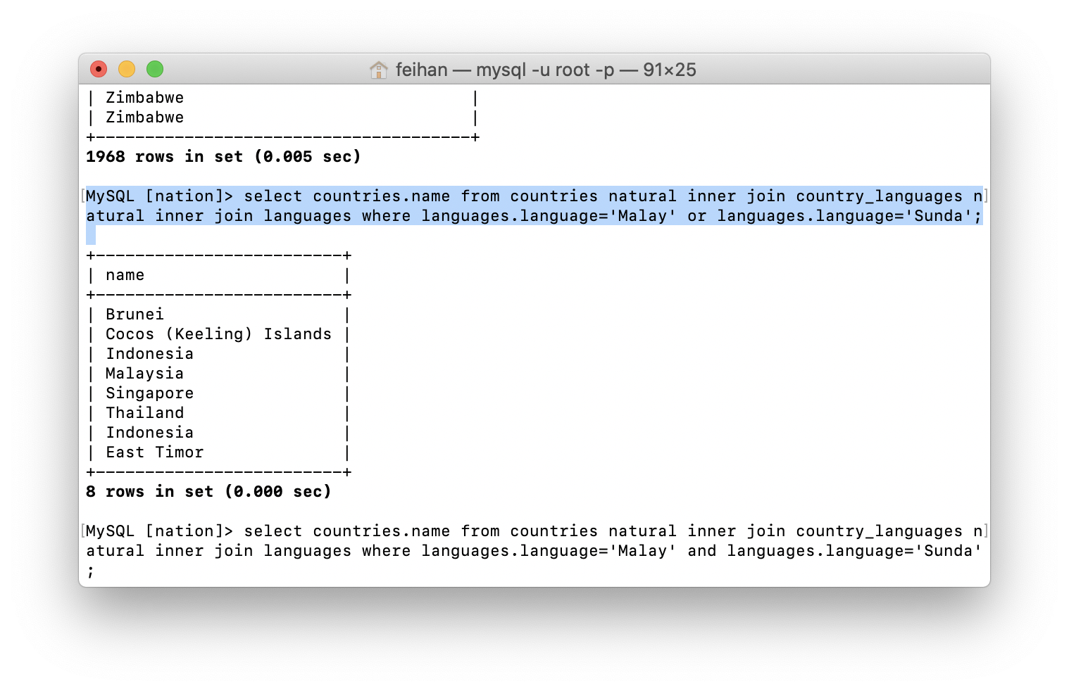

Atau

MySQL [nation]> select countries.name from countries natural inner join country_languages natural inner join languages where languages.language='Malay' and languages.language='Sunda';

(UNTUK KASUS BILA YANG DITANYA ADALAH NEGARA DENGAN BAHASA MALAY DAN BAHASA SUNDA DALAM SATU NEGARA)

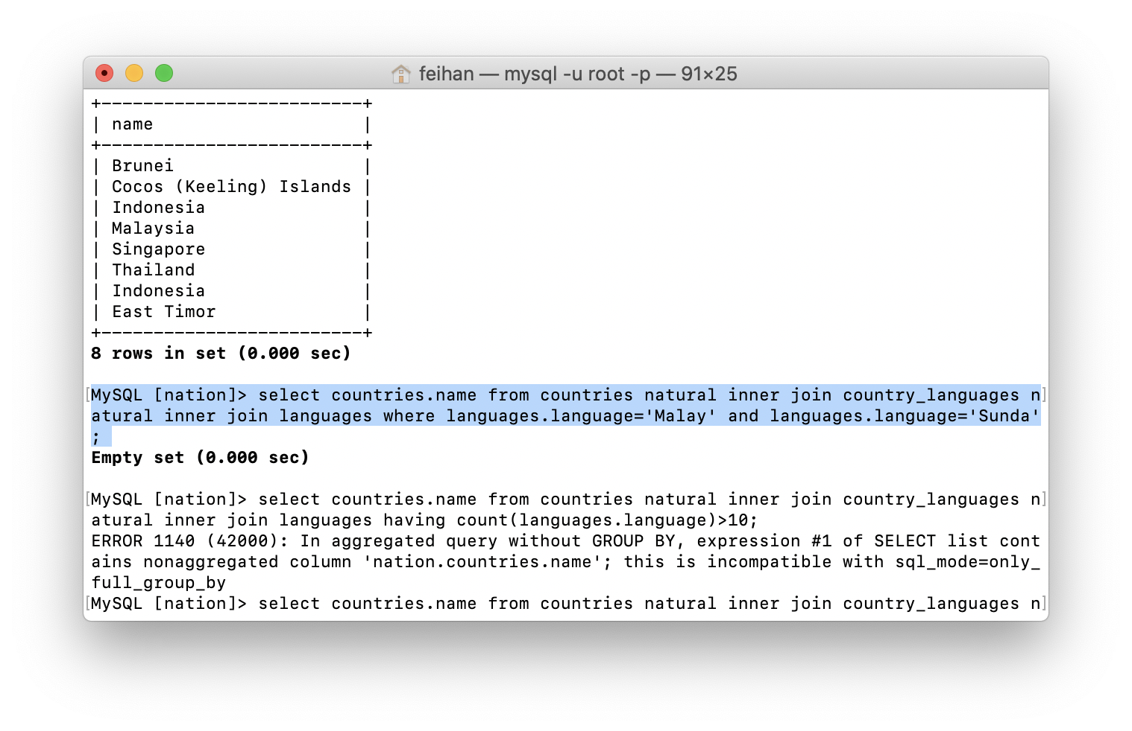

8.

MySQL [nation]> select countries.name as a,count(languages.language) from countries natural inner join country_languages natural inner join languages group by a having count(languages.language)>10;

